

AUTHOR’S NAME

## Zeeshan Anwar (160931)

**Zoya Nadeem (161000)**

**Materialized Views vs Non-Materialized Views in Contemporary Database Management Systems**

## Bachelor of Science in Computer Science

Supervisor: Shoaib Malik Co-Supervisor: Dr Tauseef

Department of Computer Science Air University, Islamabad

February 2020

©Author Name, 2020

**C e r t i f i c a t e**

We accept the work contained in the report titled “MATERIALIZED VIEWS VS NON- MATERIALIZED VIEWS IN CONTEMPORARY DATABASES”, written by Mr.

Zeeshan Anwar AND Miss Zoya Nadeem as a confirmation to the required standard for the partial fulfillment of the degree of Bachelor of Science in Computer Science.

Approved by . . . :

Supervisor: Name of the Supervisor (Title)

Internal Examiner: Name of the Internal Examiner (Title)

External Examiner: Name of the External Examiner (Title)

Project Coordinator: Name of the Project Coordinator (Title)

Head of the Department: Name of the HOD (Title)

June18*th* , 2020

# Abstract

As the world is getting more and more modernized. Data in the previous form of papers and documents are now being converted into digital form. Day by day the data is increasing in size. As the data size increases the retrieval of some particular is getting more and more complex.

People are getting more agitated as it takes a lot of time to retrieve that data. To overcome these problems views were generated in databases. Views are defined as a virtual table. It is basically a result of a stored query on the data.

As the data started growing larger and larger. Suddenly views were no longer adaptable in large data warehouses. To tackle this problem Materialized Views were introduced. Materialized views are also a database object which contains the result of a query. Materialized view better than a normal view as its approach is rather different. The query result is cached as a concrete table that may be updated from the original base tables from time to time.

In this report we will talk about Materialized views and Non-Materialized views in contemporary databases to determine which approach is better for the same dataset. We will present a method in which query response time are shown in different form of visualizations as to get a better understanding.

We will perform multiple experiments in different database management systems to determine which system is more efficient for the same dataset and the same set of queries. We will compare materialized and non-materialized views for the same query and determine which query responses faster than the other.

We will display our results in the form of tables and graph to get a better understanding of the comparison.

# Acknowledgments

We would first of all like to thank Almighty Allah for giving us the strength and opportunity to achieve the objective that we had set. We would like to thank our parents without whom it would be impossible to be here. We would like to acknowledge the support that has been given to us by our supervisor Sir Shoaib Malik for his patient and continuous guidance. We would like to show our gratitude to the faculty members of our prestigious Computer Science department for their help when we required it.

Muhammad Zeeshan Zoya Nadeem Islamabad, Pakistan

June 2020

# Contents

### Abstract ..................................................i

1. Introduction 1
   1. Background 1
   2. Problem Description 2
   3. Project Objectives 2
   4. Project Scope 3
   5. Project Lifecycle 3
2. Literature Review 4
   1. Review of Existing Research Papers 4
      1. Optimizing Queries with Materialized Views: A practical, Scalable Solution 4
      2. Optimizing Queries with Materialized Views 4
      3. Materialized Views 5
   2. Survey Table 5
   3. Conclusion 6
3. Requirement Specifications 7
   1. Existing System 7
   2. Proposed Specifications 7
   3. Data Collection 8
      1. TPC-DS 8
      2. Data Format 8

3.3.2 Data Sample 9

* 1. Hypothesis 9

1. **Design** .................................................11
   1. Research Architecture .................................................11

### System Implementation .................................................12

* 1. System Architecture .................................................12
     1. Three-Tier Architecture .................................................12
     2. Language .................................................13
     3. Libraries .................................................13
  2. Experiments Performed .................................................13
     1. Data Collection .................................................13
     2. Database Management Systems .................................................14
     3. Experiments Performed on Data .................................................14
     4. Calculating Query Response Time .................................................15

### Tables .................................................16

* 1. Graphs .20
  2. Results Analysis .................................................24

### Conclusions .25

**A User Manual** .27

**References** .36

# 

# List of Figures

1.1 Final Year Project Lifecycle..................................................................................4

1.2 Research Architecture....................................................... ....................................11

1.3 Three-Tier Architecture........................................................................................12

1.4 Postgres Graph..................................................................................................... 20

1.5 SQL Server Graph............................................................................................... 21

1.6 SQL Anywhere Graph......................................................................................... 22

1.7 Oracle SQL Graph............................................................................................... 23

# 

# 

# List of Tables

1.1 Survey.......................................................................................................................6

1.2 Postgres Materialized vs Non-Materialized views.................................................. 16

1.3 Microsoft SQL Server Materialized vs Non-Materialized views............................ 17

1.4 SQL Anywhere Materialized vs Non-Materialized views...................................... 18

1.5 Oracle SQL Materialized vs Non-Materialized views............................................ 19

# Acronyms and Abbreviations

SQL Structured Query Language

GUI Graphical User Interface

**Chapter 1**

**Introduction**

## Project Background/Overview:

To understand views, we must first talk about databases. A database is an organized collection of data, generally stored and accessed electronically from a computer system. For the retrieval of the data stored in those databases. Many languages were introduced. The language we focused on is STRUCTRED QUERY LANGUAGE (SQL). As the data grew larger and larger it became more difficult to retrieve that data efficiently and optimally.

A data warehouse is a very large database system that collects, summarizes and stores data from multiple remote and heterogeneous information sources. The decision-making queries are complex in nature and take a large amount of time when they are run against a large data warehouse. To reduce the time and cost of the queries **views** are generated.

Traditionally, views are “virtual”. The database system stores their definition queries but not their contents. Virtual views are often used to control access and provide alternative interfaces to base tables. They also support logical data independence: when the base table schema changes, views can be redefined to use the new schema, so application queries written against these views will continue to function. Over the years, however, the concept and practice of materialized views have steadily gained importance.

In a database, a view is the result set of stored queries on the data. A view does not form part of the physical schema. As a resultant set, it is a virtual table computed dynamically from data in the databases when access to the view is requested.

As the data size increases the simple views generated are not enough. For that purpose, a new method was first introduced by Oracle. That method is known as materializing the views.

Materialized views are defined as the database objects that contains the result of the query. The process of setting up a materialized view is often called view materialization. The query result is cached as a concrete table that may be updated from original base tables from time to time.

Meaning the materialized views are physically stored in databases.

Materialized views are physical structures in databases and are smaller in size. These views are usually created by database administrator which means the quality of views is dependent on the database administrator’s experience and intuition.

We materialize a view by storing its contents. Once materialized, a view can facilitate queries that use it (or can be rewritten to use it), when the base tables are expensive or even unavailable for access.

## Problem Description:

Queries posed against a large data warehouse, are typically analytic, intricate and recurring in nature. Such queries contain a lot of join operations over large volumes of records. To minimize the cost of these queries views are introduced into the system. Materialized views are an updated version of these database views. The main objective of using views is to minimize the cost of a query.

Since a materialized view is an advance form a view it is extremely fast retrieval of aggregate data, since it is precomputed and stored, at the expense of insert/update/delete. The database will keep the Materialized View in sync with the real data.

## Project Objectives:

Following are the objectives and goals of this project:

* + - Selecting various database management systems (MySQL, POSTGRES etc.).
    - Gathering the dataset from a benchmark (TPC-DS).
    - Loading the dataset into the management systems.
    - Generating materialized and non-materialized views programmatically using python programming language.
    - Calculating the runtime (query response time) using various select statements.
    - Displaying the results graphically using bar graphs.

## Project Scope:

This project aims to analyze the runtime of the queries posed against the same dataset. Firstly, we selected 4 database management systems (MySQL, POSTGRES, SQL ANYWHERE, ORACLE SQL). After selecting these database management systems, data is loaded into these individually.

After loading the dataset, the management systems were connected to a programming language(python) via a connection string. The materialized views and non-materialized views were generated programmatically for each of these database management systems.

These views were executed programmatically using select statements and the run time (query response time) was calculated by using the inbuilt functions of the programming language.

These results will then be displayed graphically using bar graphs for a better understanding.

## 

## Project Life Cycle:

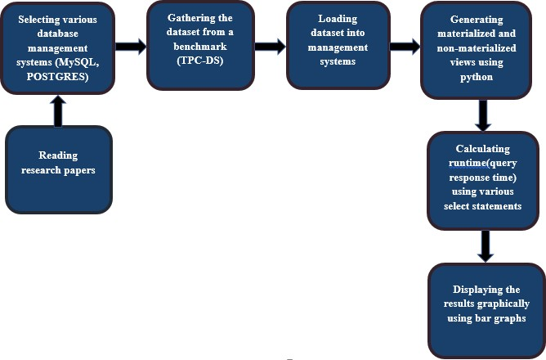

Figure 1.1: Final Year Project Lifecycle

**Chapter 2**

**Literature Review**

Our FYP focusses on views in contemporary database management systems. For this purpose, we studied various research papers that are related to materialized and non-materialized views.

## Review of Exiting Research Papers:

### Optimizing Queries Using Materialized Views: A Practical, Scalable Solution (Jonathan Goldstein & Larson, 2001)

This paper talks about how materialized views can provide massive improvements in query processing time, especially for aggregated queries over larger tables. This paper performed experiments on TPC-R benchmark. Experimental results based on an implementation in Microsoft SQL Server showed excellent results and very fast. With 1000 views in the system, average optimization time remained as low as 0.15 seconds per query.

### Optimizing Queries with Materialized Views (Sura jit Chaudhurix, Ravi Krishnamurthyy & Spyros Potamianosz, 2001)

This paper talks about of maintaining materialized views. Since all views cannot be materialized as it will take enormous space. This paper analyses the optimization problem and provides a comprehensive and efficient solution which reduces the cost of queries.

### Materialized Views (Rada Chirkova & Jun Yang, 2012)

Rada chirkova and Jun Yang in their paper “Materialized Views” talk about how In SQL settings the materialized views are considered a mature technology implemented by commercial database systems and tightly integrated into query optimization. They have covered 3 fundamental problems: Maintaining views efficiently when base tables change, using materialize views to improve performance and availability, selecting which views to materialize.

## Survey Table:

|  |  |  |
| --- | --- | --- |
| **Papers** | **Dataset** | **System** |
| **2.1.1** | TPC-R (benchmark) | SQL |
| **2.1.2** | Self-made dataset employee relation Emp (name, dno, sal, age) and a department relation Dept (dno, size, loc) | SQL |
| **2.1.3** | Self-made dataset Retailer pos (itemID, storeID, date) stores (storeID, city, region) items (itemID, name, cost) | SQL |

Table 1.1: Survey

## Conclusion:

To conclude this chapter a lot of work has been done using materialized and non-materialized views. Since materialized views have been introduced a lot of experiments have been done and their accuracy vary based on their systems. We will be performing these experiments on the same system but different database management systems to show which management system stands out. Which management system works better with materialized and non-materialized views.

**Chapter 3**

**Requirement Specifications**

Since our FYP is researched base. We had to study numerous research papers and documentations in order to find the best research till the time. Studying these research papers extensively gave us an idea as to how we should approach our problem and how can we use the best tools in order to solve it.

## Existing System:

Out of the research performed by me and my group partner we picked one research paper that benefited us the most. Materialized Views (Rada Chirkova & Jun Yang, 2011) gave us the best idea how we can approach our problem. In this paper they performed their experiments using SQL. The research covered three main factors “maintaining materialized views efficiently when the base table changes.” “using materialized views effectively to improve performance.” “selecting which views to materialize”. Since this research was done on a smaller scale the decision of which views to materialize were made by a database administrator. These experiments were performed in Microsoft SQL server.

## Proposed specifications:

Since in our base paper only used Microsoft SQL Server. We expanded our experiment to more database management systems. In order to discover the best database management system for materialized and non-materialized views. Our research will consist of a vast difference between these management systems and we will be able to distinguish the best system amongst them. Since all of these experiments will be conducted on a single operating system. The results will be unbiased.

## Data Collection:

The dataset that we will be using for our experiment was gathered from tpc.org. The name of the dataset is **TPC-DS.**

### TPC-DS:

TPC-DS is a decision support benchmark. It models several generally applicable aspects of a decision support system, including queries and data maintenance. TPC-DS is one of the first benchmarks of the Tpc benchmark which supports the idea of views.

### Data Format:

* The data was gathered from <https://github.com/databricks/tpcds-kit>.
* The data was generated in .dat files.
* The data generated was then converted into csv to import it into the database management systems.
* The scale factor used for this dataset was “SF=1” which is about 1GB of data.

### Data Sample:

A data sample of the table item.

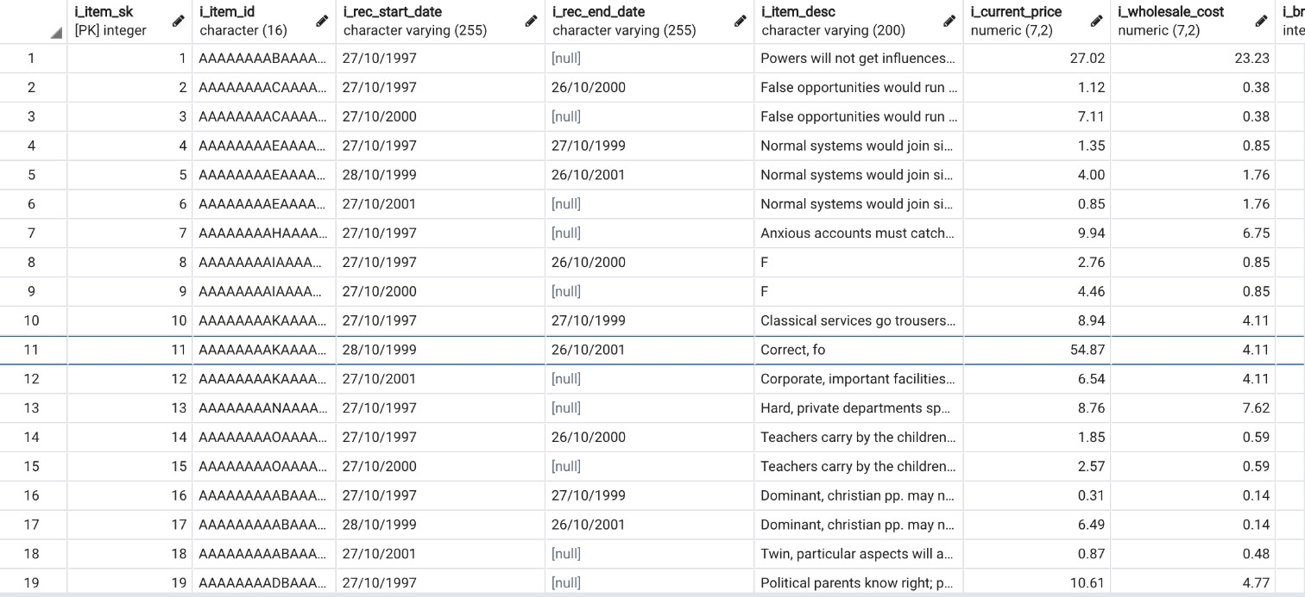

## Hypothesis:

The data was obtained in data format. Which we converted into csv files for easy import into the database management system. The data was then loaded into the database management system using INSERT queries. After that the database were connected to python programming language via a connection string. Materialized and non-materialized views were programmatically generated into the database.

**Chapter 4**

**Design**

Since our project is researched based. We do not have a specific GUI for it.

## 4.1 Research Architecture:

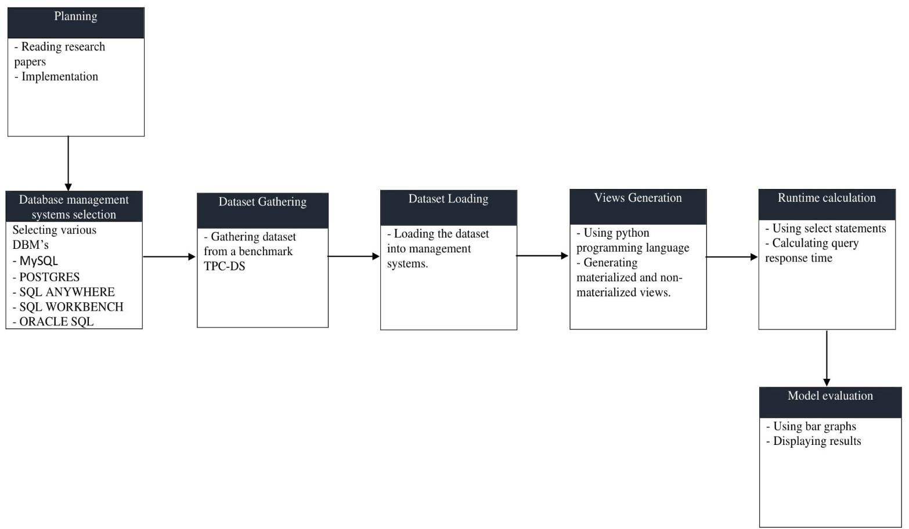

Figure 1.2: Research Architecture

**Chapter 5**

**System Implementation**

The following chapter explains the process and development study that we applied in our project. It lists the sorts of visuals that we used to represent our data and our experiments performed on that data.

## System Architecture:

Our system architecture consists of three layers. We used relational database to store our data obtained from the data source. We the experimented on that data using management studios and python programming language. We represented our results in visuals in the form of tables and graphs.

### Three-Tier Architecture:

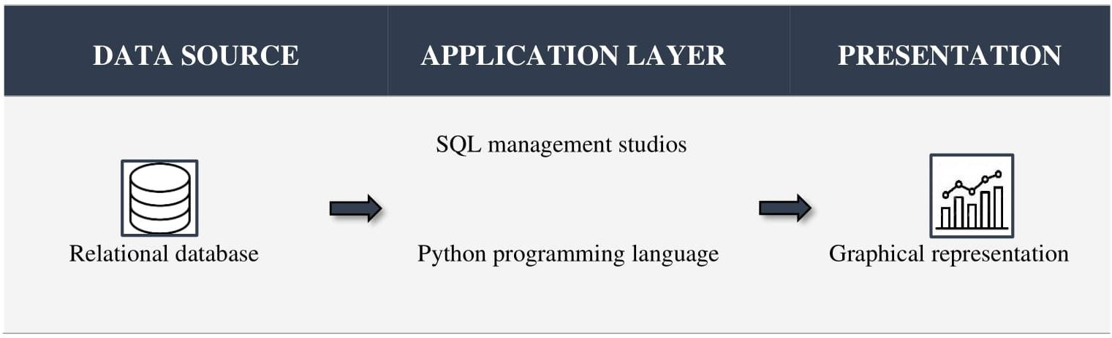

Figure 1.3: Three-Tier Architecture

### Language:

The languages we used during our projects are **SQL** and **Python**.

### Libraries:

We used the following python libraries for our project

* Psycopg2
* Pyodbc
* cx_Oracle
* mysql. Connector

## Experiments Performed:

We performed our experiments on different database management systems testing their query response time under the same environment. The query response time was then calculated individually of each database management system and compared with each other. The results were then converted into a visual form to get a better understanding.

### Data Collection:

We used TPC-DS a decision support benchmark for our dataset. The tools for generating the dataset were downloaded from <https://github.com/databricks/tpcds-kit>.

The dataset was generated from these tools using command **./dsdgen -scale 1** scale being the size of the data. We used SF=1 to generate 1 GB of data. The data was generated in .dat format. Which was then converted into csv for easy import into the databases by using Microsoft Excel.

The data was the loaded into different database management systems using their respective data importing commands.

### Database Management Systems:

We are using variety of database management systems which include

* Microsoft SQL Server Management Studio.
* PostgreSQL.
* SQL Anywhere.
* SQL Workbench.
* Oracle SQL Developer

We had to carefully choose those database management systems which support the generation of materialized views. As our whole work revolves around materialized and non-materialized views.

### Experiments Performed on Data:

We performed our experiments on this data with the help of python programming language. Python was connected to these database management systems via a connection string.

Our experiments consisted of generating materialized and non-materialized views. Which were then called in their respective queries. The materialized and non-materialized were generated programmatically into the database.

Every database management system has their own way of generating a materialized view. Following is an example of how a materialized view can be generated in Microsoft SQL Server and PostgreSQL.

### Microsoft SQL Server:

Create View Myview WITH SchemaBinding

AS SELECT COL1, SUM(COL2)

From <table-name> GROUP BY COL1

### PostgreSQL:

Create MATERIALIZED VIEW MyView AS SELECT COL1,COL2

FROM <table-name> GROUP BY COL2

These views were then called into various SQL statements. These SQL statements were specifically generated for these views.

### Calculating Query Response Time:

The query response time for different database management systems was calculated in python using inbuilt libraries. The time was calculated for the SQL statements which were calling a view. Both materialized and non-materialized views were tested with those SQL statements and the response time was noted down. These response times were then converted into tabular and graphical representation.

## Tables:

|  |  |  |
| --- | --- | --- |
| **View Name** | **View Type** | **Time in milliseconds** |
| ccv | Materialized view | 19 |
| Non-Materialized view | 30 |
| itemv | Materialized view | 17 |
| Non-Materialized view | 29 |
| promv | Materialized view | 22 |
| Non-Materialized view | 27 |
| storv | Materialized view | 22 |
| Non-Materialized view | 34 |
| wrhsv | Materialized view | 13 |
| Non-Materialized view | 18 |
| websv | Materialized view | 16 |
| Non-Materialized view | 31 |
| webv | Materialized view | 22 |
| Non-Materialized view | 28 |
| crv | Materialized view | 42 |
| Non-Materialized view | 165 |
| csv | Materialized view | 210 |
| Non-Materialized view | 431 |
| srv | Materialized view | 58 |
| Non-Materialized view | 175 |
| ssv | Materialized view | 210 |
| Non-Materialized view | 633 |
| wrv | Materialized view | 34 |
| Non-Materialized view | 191 |
| wsv | Materialized view | 110 |
| Non-Materialized view | 370 |

Table 1.2: Postgres Materialized vs Non-Materialized views

|  |  |  |
| --- | --- | --- |
| **View Name** | **View Type** | **Time in milliseconds** |
| ccv | Materialized view | 120 |
| Non-Materialized view | 166 |
| itemv | Materialized view | 156 |
| Non-Materialized view | 42 |
| promv | Materialized view | 370 |
| Non-Materialized view | 468 |
| storv | Materialized view | 139 |
| Non-Materialized view | 190 |
| wrhsv | Materialized view | 155 |
| Non-Materialized view | 152 |
| websv | Materialized view | 312 |
| Non-Materialized view | 596 |
| webv | Materialized view | 156 |
| Non-Materialized view | 130 |
| crv | Materialized view | 172 |
| Non-Materialized view | 245 |
| csv | Materialized view | 460 |
| Non-Materialized view | 932 |
| srv | Materialized view | 1317 |
| Non-Materialized view | 3714 |
| ssv | Materialized view | 1098 |
| Non-Materialized view | 2999 |
| wrv | Materialized view | 5441 |
| Non-Materialized view | 1700 |
| wsv | Materialized view | 4309 |
| Non-Materialized view | 2969 |

Table 1.3: Microsoft SQL Server Materialized vs Non-Materialized views

|  |  |  |
| --- | --- | --- |
| **View Name** | **View Type** | **Time in milliseconds** |
| ccv | Materialized view | 70 |
| Non-Materialized view | 556 |
| itemv | Materialized view | 46 |
| Non-Materialized view | 73 |
| promv | Materialized view | 70 |
| Non-Materialized view | 38 |
| storv | Materialized view | 38 |
| Non-Materialized view | 75 |
| wrhsv | Materialized view | 37 |
| Non-Materialized view | 39 |
| websv | Materialized view | 38 |
| Non-Materialized view | 42 |
| webv | Materialized view | 30 |
| Non-Materialized view | 34 |
| crv | Materialized view | 61 |
| Non-Materialized view | 105 |
| csv | Materialized view | 36 |
| Non-Materialized view | 40 |
| srv | Materialized view | 40 |
| Non-Materialized view | 87 |
| ssv | Materialized view | 95 |
| Non-Materialized view | 105 |
| wrv | Materialized view | 70 |
| Non-Materialized view | 91 |
| wsv | Materialized view | 110 |
| Non-Materialized view | 150 |

Table 1.4: SQL Anywhere Materialized vs Non-Materialized views

|  |  |  |
| --- | --- | --- |
| **View Name** | **View Type** | **Time in milliseconds** |
| ccv | Materialized view | 20 |
| Non-Materialized view | 35 |
| itemv | Materialized view | 22 |
| Non-Materialized view | 29 |
| promv | Materialized view | 20 |
| Non-Materialized view | 29 |
| storv | Materialized view | 25 |
| Non-Materialized view | 39 |
| wrhsv | Materialized view | 17 |
| Non-Materialized view | 23 |
| websv | Materialized view | 22 |
| Non-Materialized view | 28 |
| webv | Materialized view | 31 |
| Non-Materialized view | 39 |
| crv | Materialized view | 30 |
| Non-Materialized view | 45 |
| csv | Materialized view | 38 |
| Non-Materialized view | 95 |
| srv | Materialized view | 58 |
| Non-Materialized view | 140 |
| ssv | Materialized view | 190 |
| Non-Materialized view | 473 |
| wrv | Materialized view | 28 |
| Non-Materialized view | 139 |
| wsv | Materialized view | 100 |
| Non-Materialized view | 247 |

Table 1.5: Oracle SQL Materialized vs Non-Materialized views

## Graphs:

Following is the graphical representation of the results we achieved during our experiments.

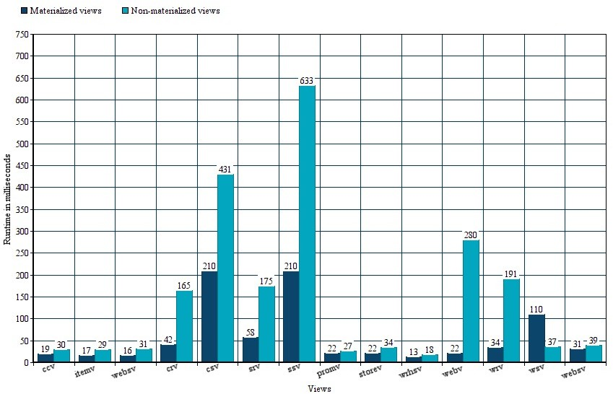

### FIGURE 1.4: Query Response Time for POSTGRES Materialized and Non-Materialized Views

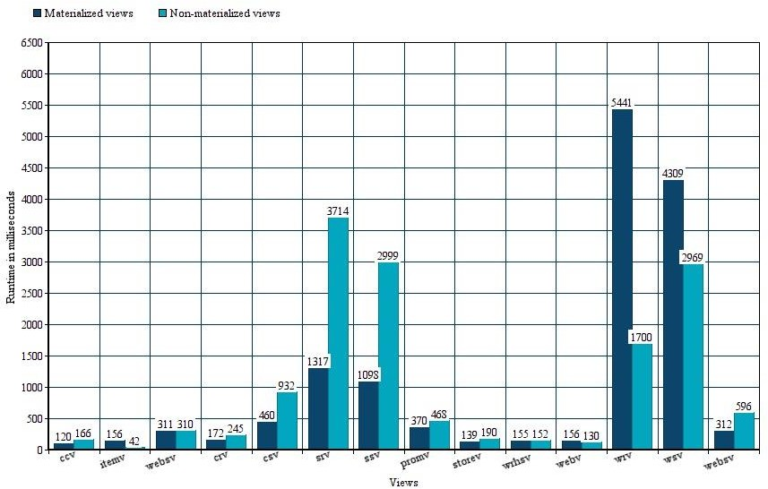

FIGURE 1.5: Query Response Time for SQL SERVER MANAGEMENT STUDIO

Materialized and Non-Materialized Views

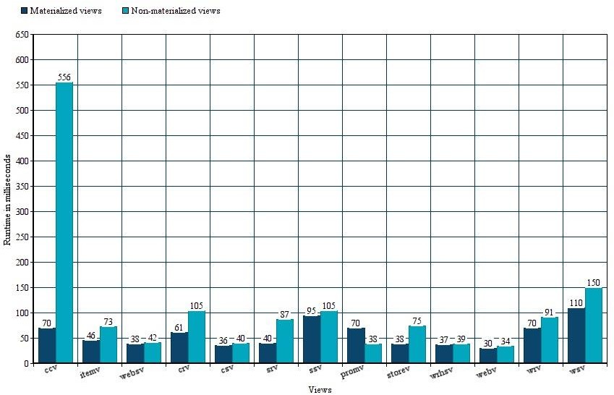

FIGURE 1.6: Query Response Time for SQL ANYWHERE Materialized and

Non-Materialized Views

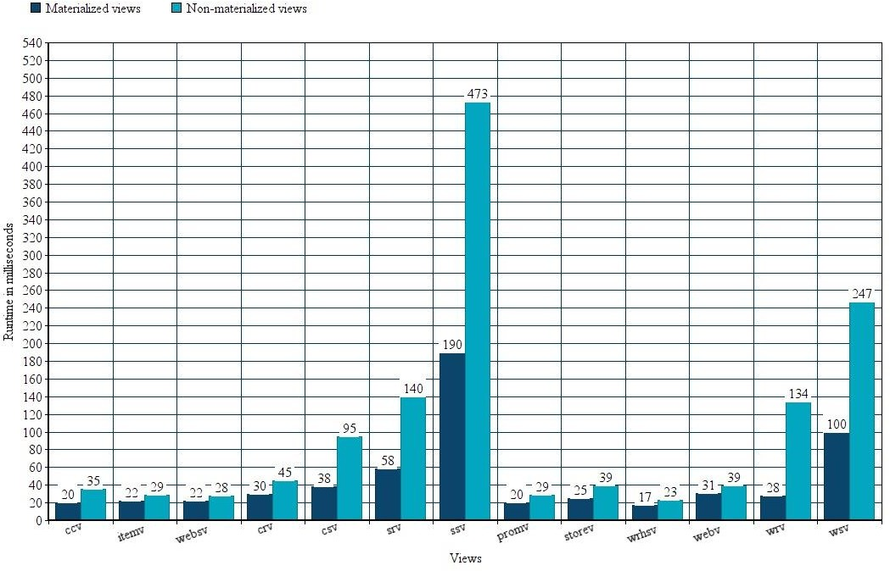

FIGURE 1.7: Query Response Time for ORACLE SQL Materialized and

Non-Materialized Views.

* 1. **Result Analysis:**

According to our research and experiment results we can clearly see that materialized views are far better than non-materialized views. However, in some cases the non-materialized view response time is better than the materialized view.

That is why the database administrator must know which views to materialize and which views to not to. Since materializing all views will take up very much space therefore defeating the purpose of creating them.

We have provided our results of different database management systems. These results vary due to the difference in response times of these management systems. As we can clearly see that some database management systems are way ahead in their response time from others.

Although it also depends on the system on which these management systems are ran. We ran these experiments on a single system providing a fair environment for each database management system.

**Chapter 6**

**Conclusions**

This was a brief report detailing our project “Materialized vs Non-Materialized views in contemporary databases”. In which we detailed that we aim to achieve i.e Generation of materialized views. Generation of non-materialized views. Comparing the response time of these views programmatically. We have performed our experiment on different database management systems and compared their response times.

We gathered different database management systems which use “STRUCTURED QUERY LANGUAGE” (SQL) to perform our experiments. We connected our databases to python programming language via a connection string. After connecting with the database management systems, we started our experiments.

We generated materialized and non-materialized views programmatically through python. After generating these views, we ran multiple different queries on these views. We calculated the query response time using python’s inbuilt functions.

We calculated accurate results of every query which used materialized and non-materialized views. The response time was calculated in milliseconds. These results were displayed in the form of tables and graphs. Since we calculated our results on the same system to provide a fair environment for our database management systems, we can say that the accuracy of our results is satisfying.

We achieved our goal of providing results between the response time of materialized and non- materialized views. We can say that which database management system was the best by looking at our results. But since the database management systems depend on the environment, they are used in we are more focused on the response times of materialized and non-materialized views. We cannot say which database management system is the best based on our single system environment.

Since in our experiments the views were generated and selected by the database administrator. For our future work we can focus on generating and selecting these views automatically using artificially using either machine learning or artificial intelligence. As the world is converting its data into digital form the data is going to keep on increasing. We need to focus on how we are going to maintain that data. Since data is growing larger by the day. It will be very optimal if we can automate the maintenance of this data using modern technology.

**Appendix A**

**User Manual**

Following is a step by step guide on how to perform the above-mentioned experiments.

## Step 1:

Download the tpc-ds benchmark from <https://github.com/databricks/tpcds-kit>

## 

## Step 2:

After downloading and extracting the benchmark open the tools folder in the tpc-ds kit folder and run an executable file called MAKEFILE.

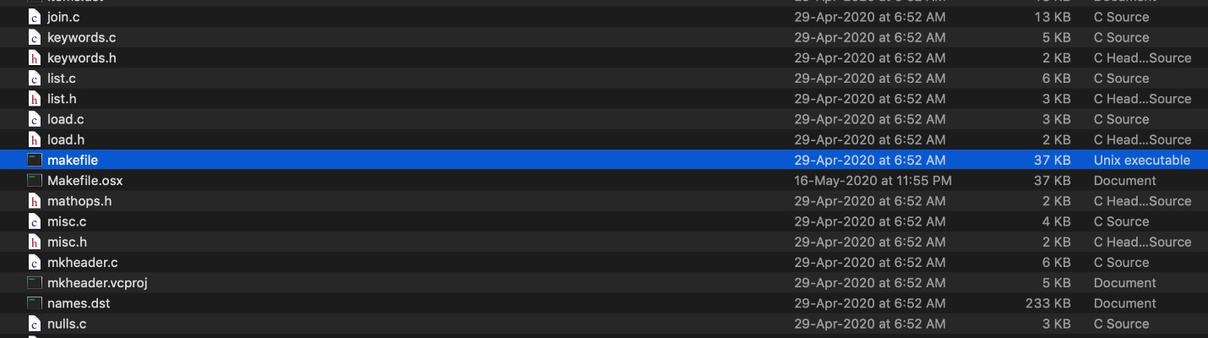

## 

## Step 3:

After running the make file. Open up terminal (or command prompt if using windows) go into the tpcds tools directory. In the tools directory run command “ ./dsdgen – scale 100 -dir/tmp” Scale defines the amount of data you need to generate. The official scale factors are 1TB, TB, 10 TB etc. We generated a total of 1gb data so we used SF= 1. -dir/tmp defines which directory to store the generated data in.

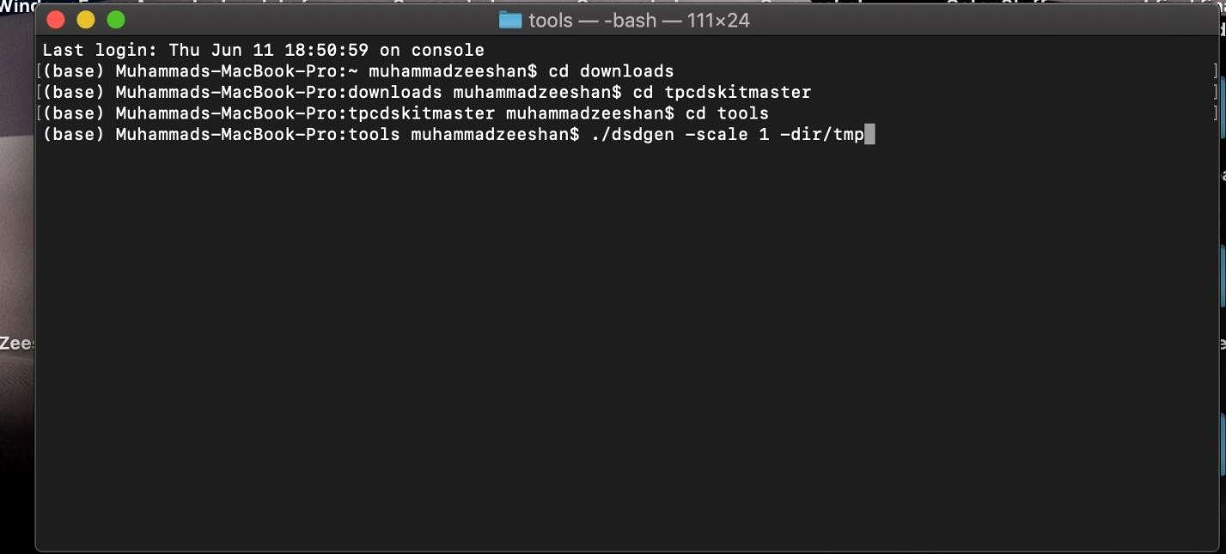

## Step 4:

The files generated from the dsdgen are in .dat format which are then converted into csv files using Microsoft Excel. The columns are delimited by “|”

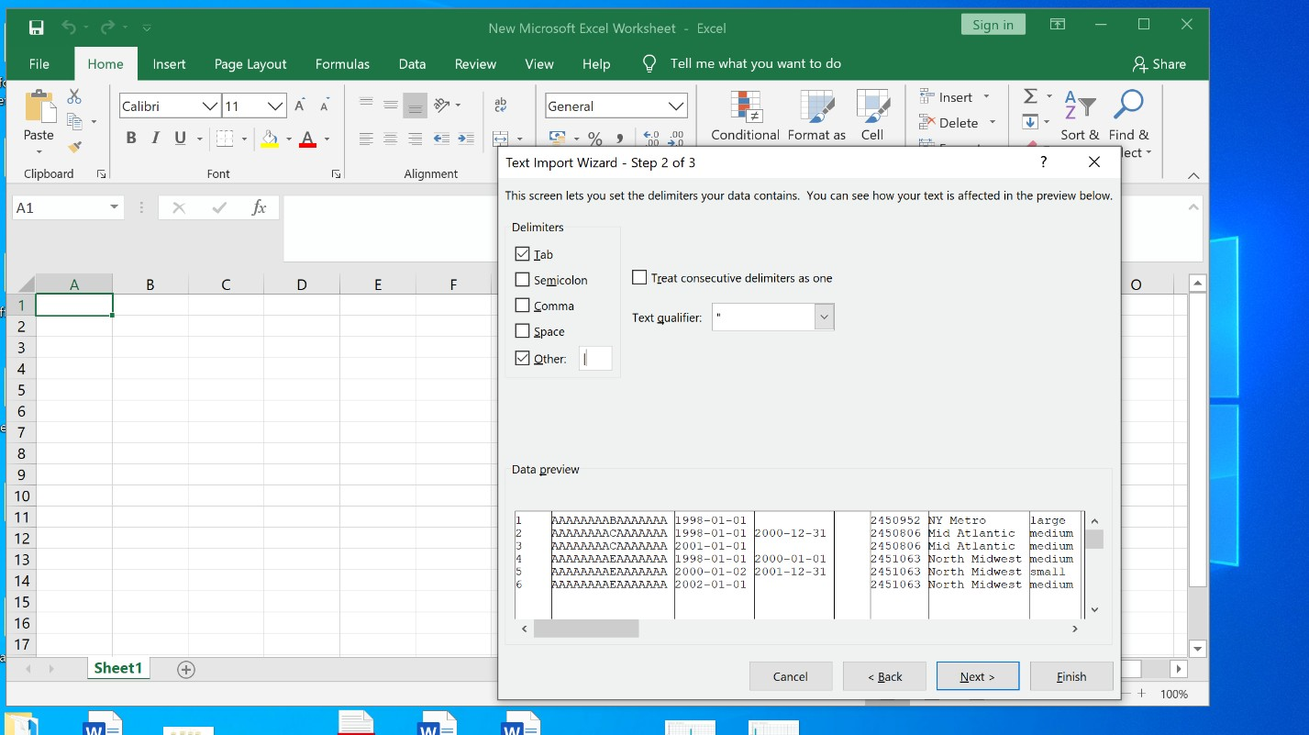

## Step 5:

After you have generated the dataset. Download any database management studio which support View Materialization. For this manual purpose I will be using POSTGRES.

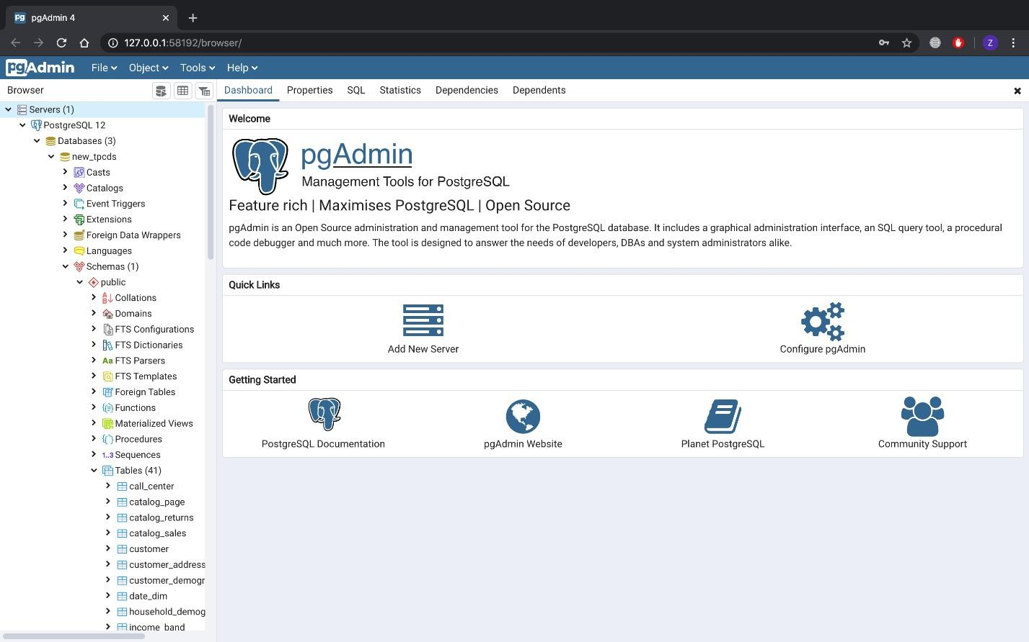

## Step 6:

Create a database in the database management system and create tales. The create table SQL queries are provided in the tpcds-tools folder named “tpcds source.sql”. After creating the tables import the data into those tables.

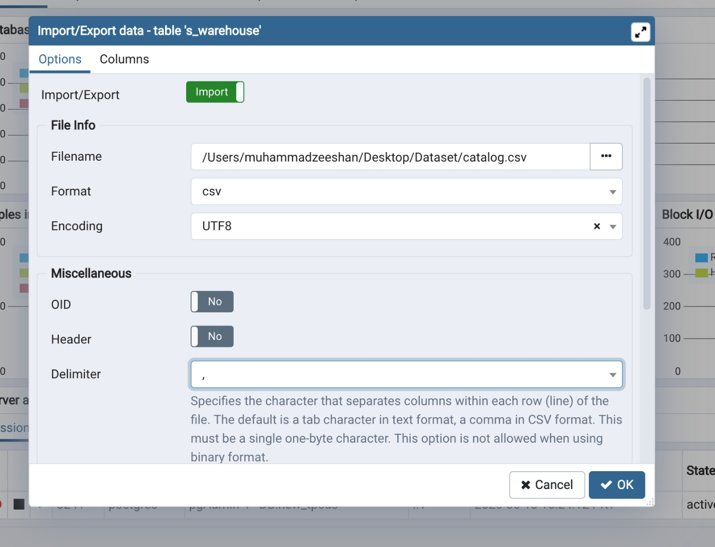

## Step 7:

Connect the database management system with python programming language using appropriate connection string. For every database management system the connection string varies.

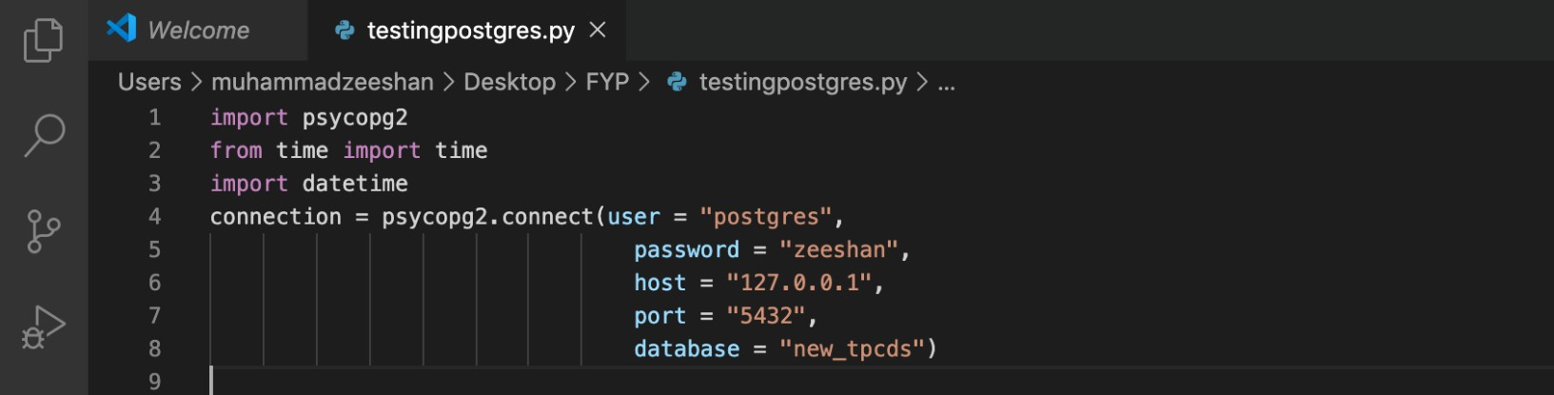

## Step 8:

After connecting with python generate materialized and non-materialized views into the database management system. The view queries can be found in tpc-ds documentation found on [www.tpc.org](http://www.tpc.org/)

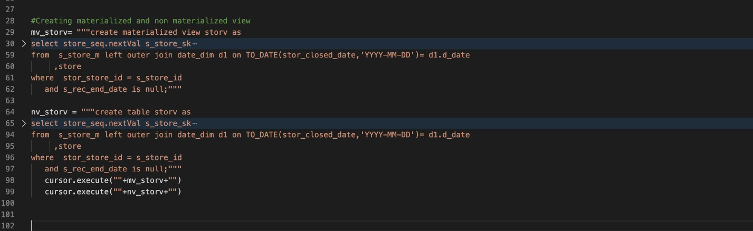

## Step 9:

After generating views. Execute the select queries which use these views in them. Those queries can be found in tpcds/tests folder with “sql” extension. Calculate the execution time of these queries using in built functions of Python.

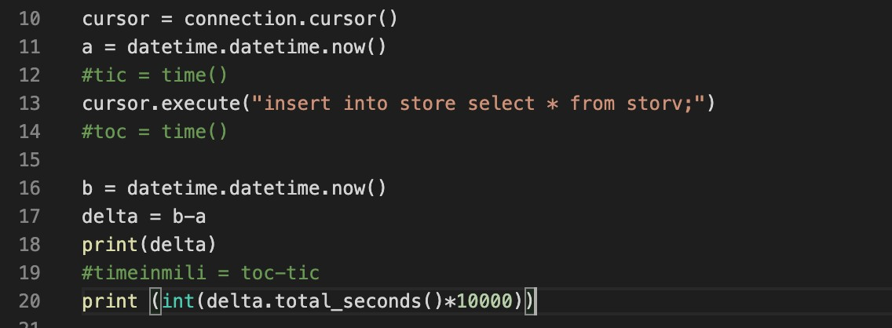

## Step 10:

Display the time calculated in the form of tables and graphs.



# References

1. Jonathan Goldstein & Per-Ake Larson. Optimizing Queries Using Materialized Views: A Practical Scalable Solution,2001. Microsoft Research, One Microsoft Way, Redmond, WA 98052.
2. Surajid Chaudhuri, Ravi Krishnamurthy, Spyros Potamianos & Kyuseok Shim. Optimizing Queries With Materialized Views, 2001. Microsoft Research, Redmond, WA. Hewlett-Packard Laboratories, Palo Alto, CA. Momferatory 71, Athens, Greece. IBM Almdaen Research Center, San Jose, CA.
3. Rada Chirkova, Jun Yang. Materialized Views, November 2012. Now Publishers Inc, P.O. Box 1024, Hanover, MA, United States.